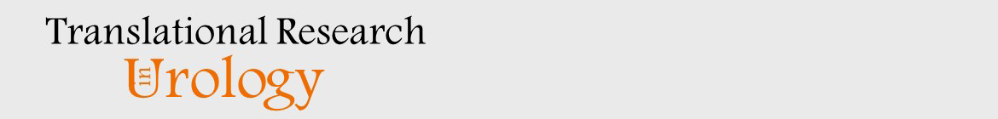
CHANGE OF AUTHORSHIP FORM
Only Before Proof Approval

Manuscript Title:
Running Head:

Corresponding Author:

Please check all that apply.

New author(s) have been added.
There is a change in the order of authorship.
An author wishes to remove his/her name. An author’s name may only be removed at his/her own request in writing.

ORIGINAL AUTHORSHIP

List ALL AUTHORS in the same order as the original (first) submission.

Print Name | Print Name
Name (1) | Name (6)
Name (2) | Name (7)
Name (3) | Name (8)
Name (4) | Name (9)
Name (5) | Name (10)

NEW AUTHORSHIP

List the ALL AUTHORS in same order as the new version.

Print Name | Print Name
Name (1) | Name (6)
Name (2) | Name (7)
Name (3) | Name (8)
Name (4) | Name (9)
Name (5) | Name (10)

I attest that:

- The manuscript is not currently under consideration, in press, or published elsewhere, and the research reported will
not be submitted for publication elsewhere until a final decision has been made as to its acceptability by the journal
(posting of submitted material on a web site may be considered prior publication-note this in your cover letter).
- The manuscript is truthfully original work without fabrication, fraud, or plagiarism.
- I have made an important scientific contribution to the study and am thoroughly familiar with the primary data.
- I have read the complete manuscript and take responsibility for the content and completeness of the manuscript and
understand that I share responsibility if the paper, or part of the paper, is found to be faulty or fraudulent.

Corresponding Author Name Signature Date

